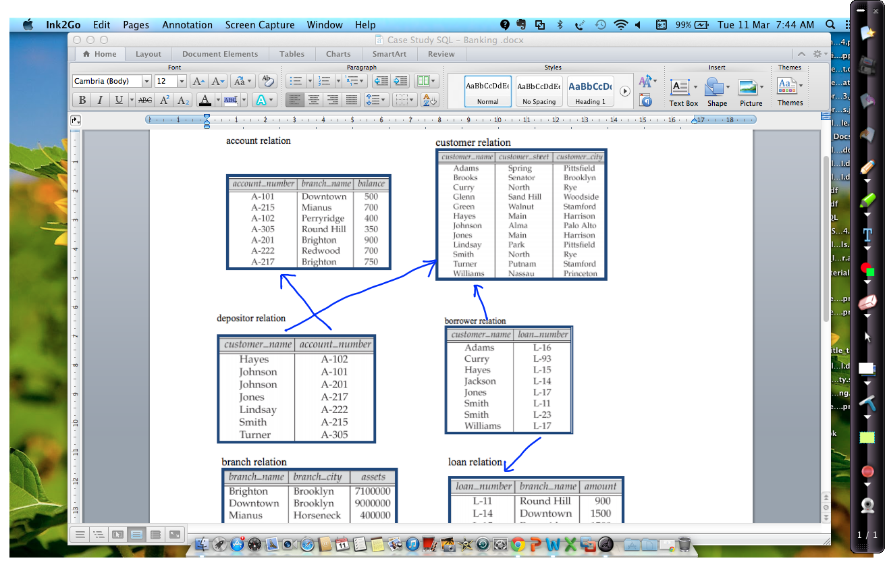

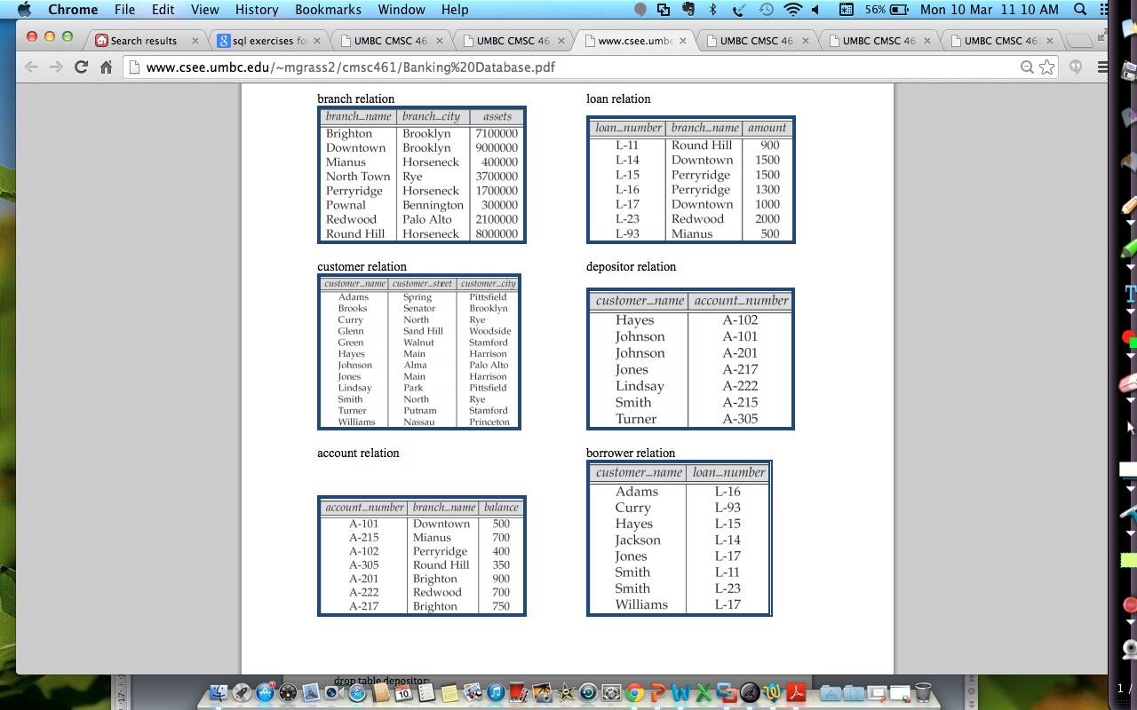

Write SQL for the following.

1. The names and cities of all borrowers.

2. The names of borrowers who live in Rye.

3. The names of customers who live in the same city as at least one other customer.

4. Find the name, city, and assets of the branch with the largest assets.

5. The names and cities of customers who have a loan at Perryridge branch.

6. Find the number of accounts with balances between 700 and 900.

7. The names of customers with both accounts and loans at Perryridge branch.

8. The customers whose total loans are greater than the total amount in their bank accounts

9. The branch cities in reverse alphabetical order and all uppercase letters.

10. The names of customers living on streets with names ending in "Hill".

11. The names of customers with an account but not a loan at Perryridge branch.

12. The names of customers with accounts at a branch where Hayes has one.

13. The names of branches whose assets are greater than the assets of all branches in Brooklyn.

14. The branch(es) with the largest average balance.

15. Get the names of customers with an account but not a loan at Perryridge branch.

16. The branch name and number of customers for each branch

17. Deposit an additional 20 dollars to TURNER’s bank account. ( Make the change permanent.)